Gun Range + Cape Town City Tour
Perfect for travellers who want action plus sightseeing.
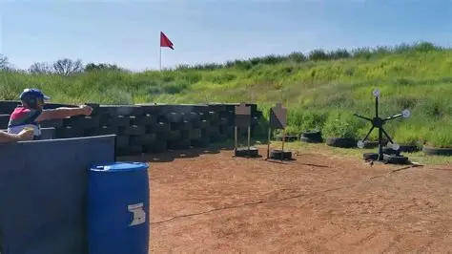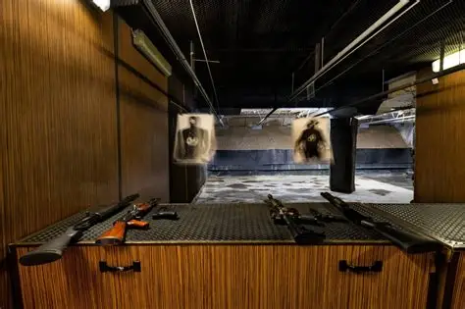
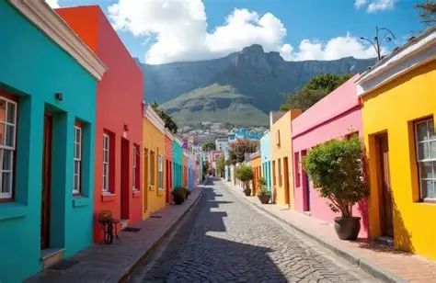
Tour Overview
Start with a shooting experience, then explore Cape Town’s most iconic viewpoints.
Itinerary
- Shooting range session
- Bo‑Kaap
- Signal Hill
- Camps Bay
- V&A Waterfront
Inclusions
- Private transport
- Shooting range session
- Driver‑guide
- Bottled Water
Exclusions
Meals.
Optional museum entries
Price
2–4 guests: R7,200 total
5–7 guests: R10,000 total

